**1.Write a program to read in two integers and perform the following operations on them: addition, subtraction, multiplication, division, and modulo.**

**Program:**

#include <iostream>

using namespace std;

int main() {

int num1, num2, sum, difference, product, quotient;

cout<< "Enter first number: ";

cin>> num1;

cout<< "Enter second number: ";

cin>> num2;

sum = num1 + num2;

difference = num1 - num2;

product = num1 * num2;

if (num2 != 0) {

quotient = num1 / num2;

cout<< "Quotient: " << quotient <<endl;

} else {

cout<< "Cannot divide by zero!" <<endl;

}

cout<< "Sum: " << sum <<endl;

cout<< "Difference: " << difference <<endl;

cout<< "Product: " << product <<endl;

return 0;

}

**Output:**

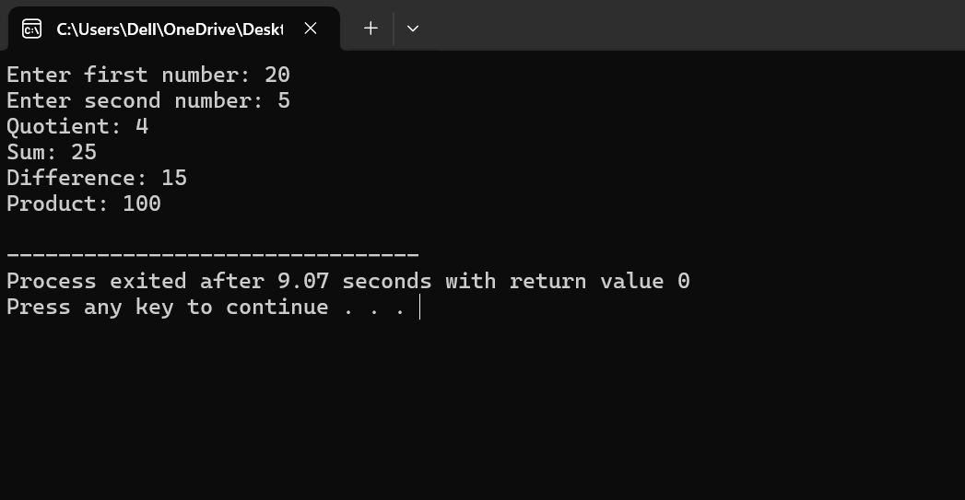

**2.Program to determine the integer is odd or even.**

**Program:**

#include <iostream>

using namespace std;

int main() {

int num;

cout<< "Enter an integer: ";

cin>>num;

if(num % 2 == 0) {

cout<<num<< " is even." <<endl;

} else {

cout<<num<< " is odd." <<endl;

}

return 0;

}

**Output:**

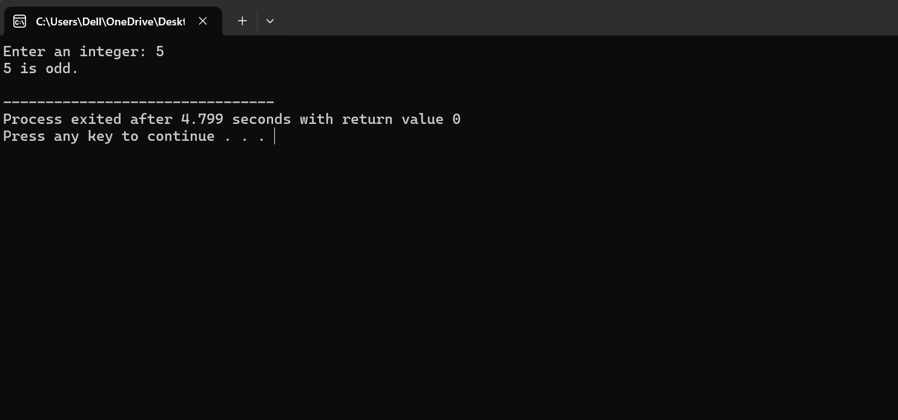

**3.Program to compute the average of three integers.**

**Program:**

#include <iostream>

using namespace std;

int main() {

int num1, num2, num3;

float average;

cout<< "Enter first number: ";

cin>> num1;

cout<< "Enter second number: ";

cin>> num2;

cout<< "Enter third number: ";

cin>> num3;

average = (num1 + num2 + num3) / 3.0;

cout<< "The average of " << num1 << ", " << num2 << ", and " << num3 << " is " << average <<endl;

return 0;

}

**Output:**

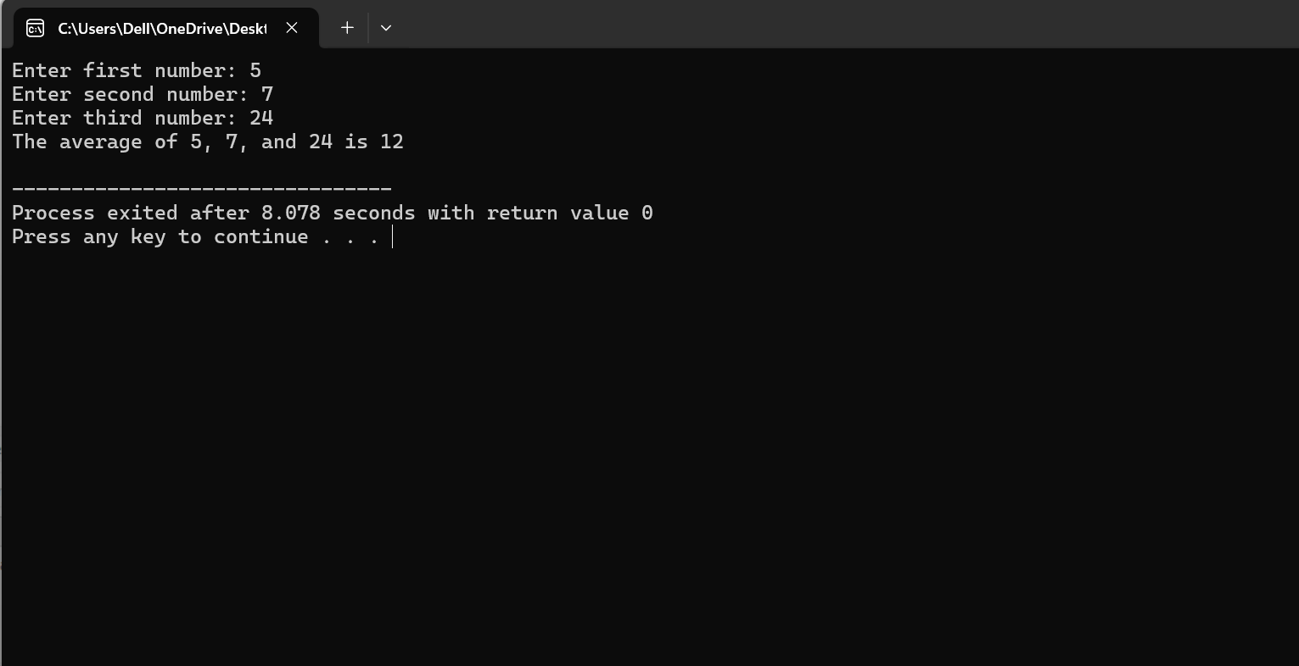

**4.Program to check two numbers are equal or not.**

**Program:**

#include <iostream>

using namespace std;

int main() {

int num1, num2;

cout<< "Enter first number: ";

cin>> num1;

cout<< "Enter second number: ";

cin>> num2;

if (num1 == num2) {

cout<< "The numbers " << num1 << " and " << num2 << " are equal." <<endl;

} else {

cout<< "The numbers " << num1 << " and " << num2 << " are not equal." <<endl;

}

return 0;

}

**Output:**

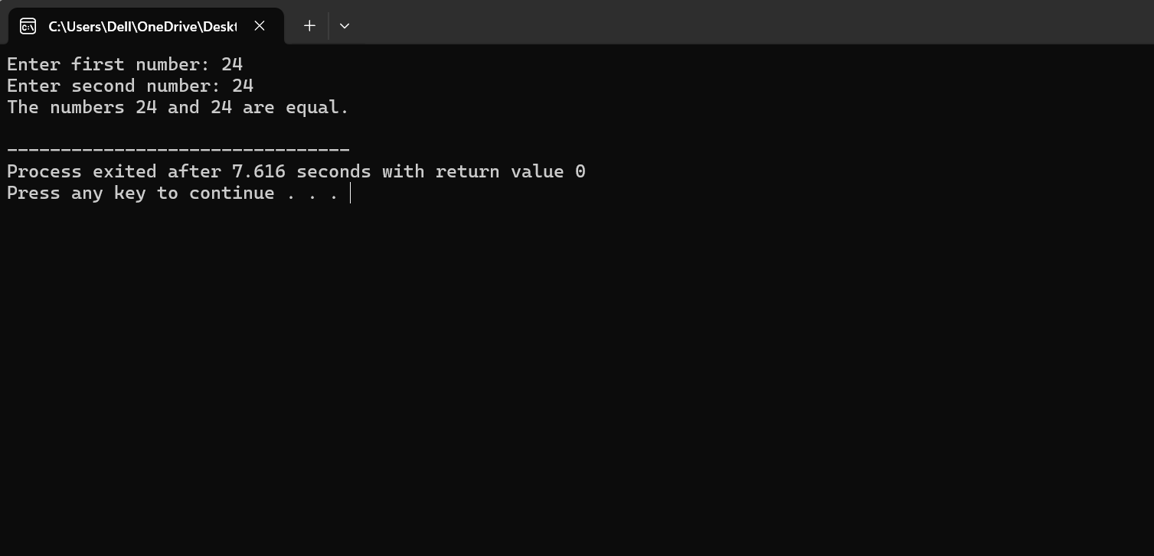

**5.Write a program to read in two Floating numbers and perform the following operations on them: addition, subtraction, multiplication, division, and modulo.**

**Program:**

#include <iostream>

#include <cmath>

using namespace std;

int main() {

float num1, num2;

cout<< "Enter first number: ";

cin>> num1;

cout<< "Enter second number: ";

cin>> num2;

float addition = num1 + num2;

cout<< "Addition: " << num1 << " + " << num2 << " = " << addition <<endl;

float subtraction = num1 - num2;

cout<< "Subtraction: " << num1 << " - " << num2 << " = " << subtraction <<endl;

float multiplication = num1 * num2;

cout<< "Multiplication: " << num1 << " * " << num2 << " = " << multiplication <<endl;

if (num2 != 0) {

float division = num1 / num2;

cout<< "Division: " << num1 << " / " << num2 << " = " << division <<endl;

} else {

cout<< "Error: Division by zero is not allowed." <<endl;

}

float modulo = fmod(num1, num2);

cout<< "Modulo: fmod(" << num1 << ", " << num2 << ") = " << modulo <<endl;

return 0;

}

**Output:**

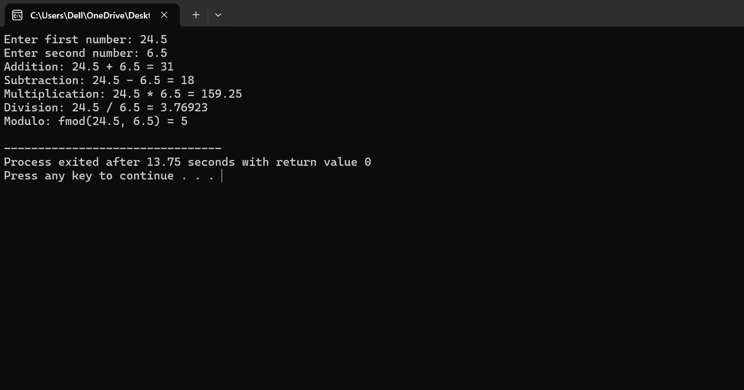

**6. Program to check the character is a vowel or consonant.**

**Program:**

#include <iostream>

using namespace std;

int main() {

char ch;

cout<< "Enter a character: ";

cin>>ch;

ch = tolower(ch);

if (ch == 'a' || ch == 'e' || ch == 'i' || ch == 'o' || ch == 'u') {

cout<<ch<< " is a vowel." <<endl;

}

else if ((ch>= 'a' &&ch<= 'z') || (ch>= 'A' &&ch<= 'Z')) {

cout<<ch<< " is a consonant." <<endl;

}

else {

cout<<ch<< " is not an alphabet letter." <<endl;

}

return 0;

}

**Output:**

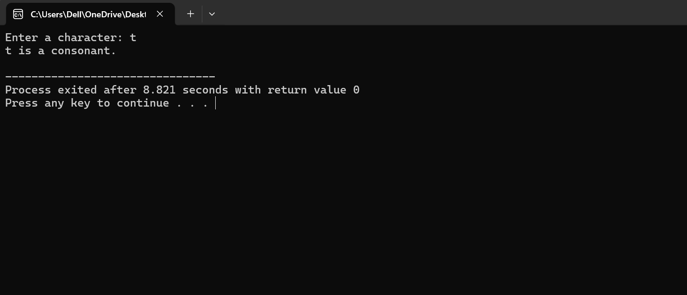

**7.Program to check the number is positive, negative or zero.**

**Program:**

#include <iostream>

using namespace std;

int main() {

float num;

cout<< "Enter a number: ";

cin>>num;

if (num> 0) {

cout<< "The number " <<num<< " is positive." <<endl;

} else if (num< 0) {

cout<< "The number " <<num<< " is negative." <<endl;

} else {

cout<< "The number is zero." <<endl;

}

return 0;

}

**Output:**

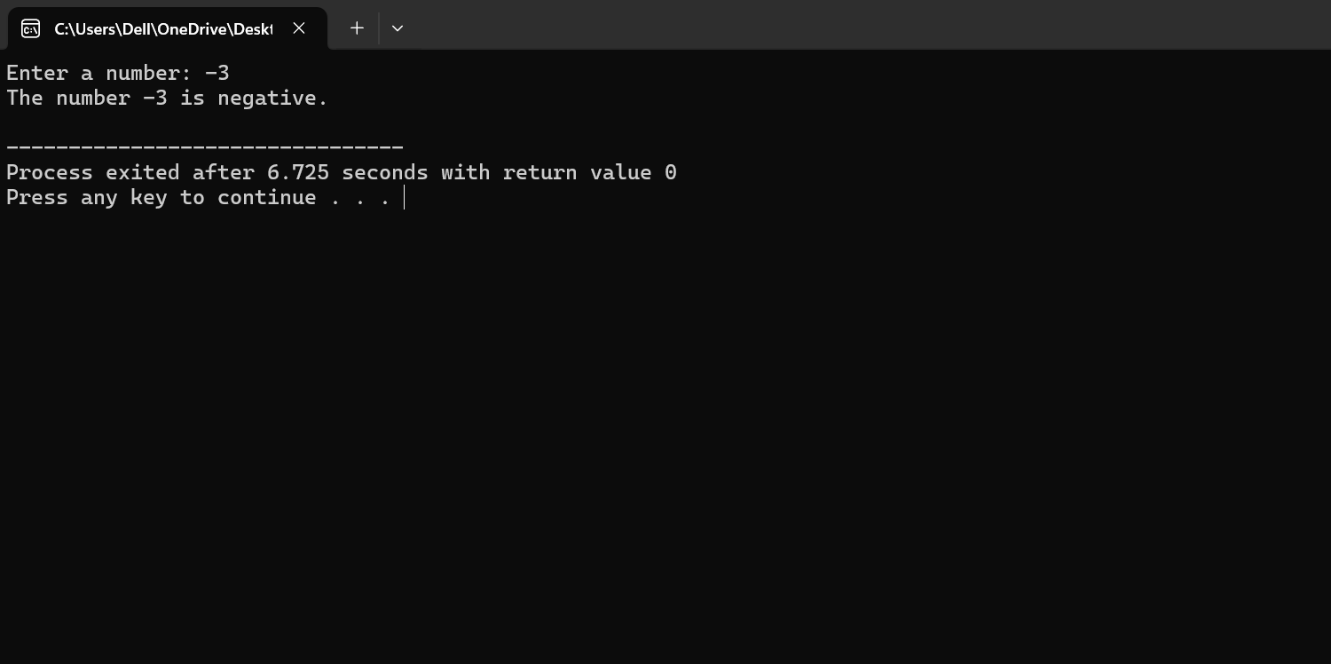

**8.Program to determine which number is greater among two integers.**

**Program:**

#include <iostream>

using namespace std;

int main() {

int num1, num2;

cout<< "Enter first number: ";

cin>> num1;

cout<< "Enter second number: ";

cin>> num2;

if (num1 > num2) {

cout<< "The greater number is: " << num1 <<endl;

} else if (num2 > num1) {

cout<< "The greater number is: " << num2 <<endl;

} else {

cout<< "Both numbers are equal." <<endl;

} return 0;

}

**Output:** 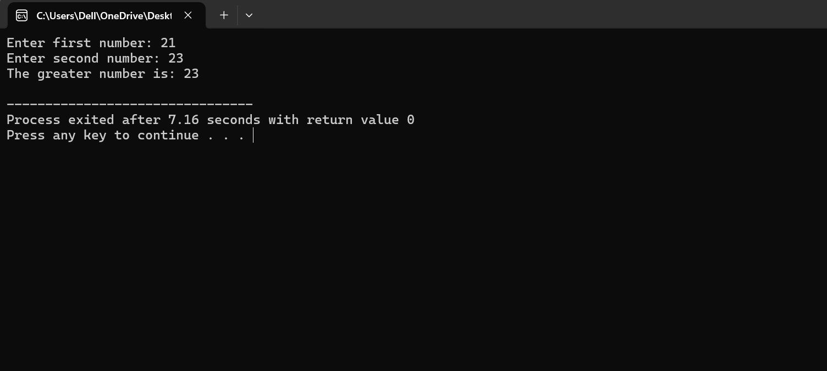

**9.Program to read a floating-number and round it to the nearest integer using the floor an ceil functions.**

**Program:**

#include <iostream>

#include <cmath>

using namespace std;

int main() {

float num;

cout<< "Enter a floating-point number: ";

cin>>num;

int floored = floor(num);

cout<< "Using floor, the number rounded down is: " << floored <<endl;

int ceiled = ceil(num);

cout<< "Using ceil, the number rounded up is: " << ceiled <<endl;

int rounded = round(num);

cout<< "Using round, the number rounded to the nearest integer is: " << rounded <<endl;

return 0;

}

**Output:**

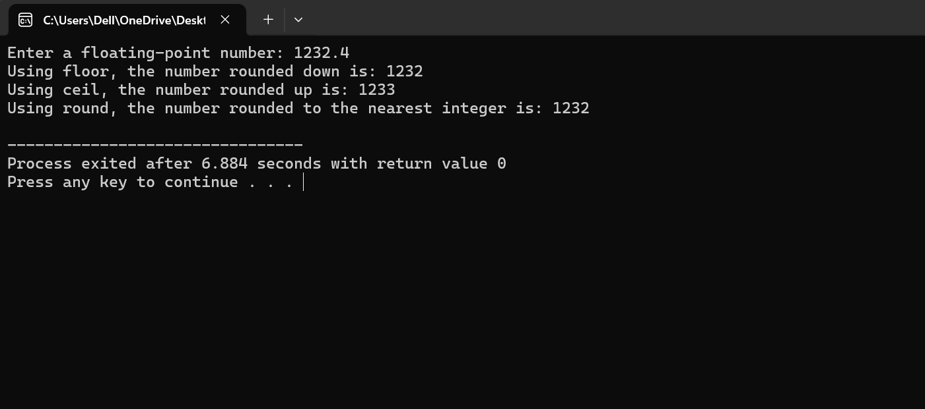

**10.Program to swap two numbers using bitwise XOR operator.**

**Program:**

#include <iostream>

using namespace std;

int main() {

int num1, num2;

cout<< "Enter first number: ";

cin>> num1;

cout<< "Enter second number: ";

cin>> num2;

cout<< "Before swapping:" <<endl;

cout<< "num1 = " << num1 << ", num2 = " << num2 <<endl;

num1 = num1 ^ num2;

num2 = num1 ^ num2;

num1 = num1 ^ num2;

cout<< "After swapping:" <<endl;

cout<< "num1 = " << num1 << ", num2 = " << num2 <<endl;

return 0;

}

**Output:**

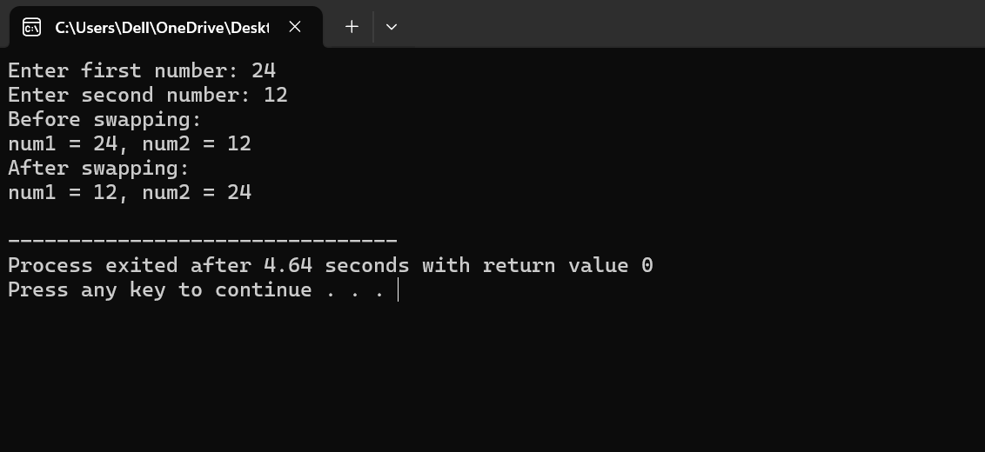

**11.Largest among three numbers using ternary conditional operator.**

**Program:**

#include <iostream>

using namespace std;

int main() {

int num1, num2, num3, largest;

cout<< "Enter first number: ";

cin>> num1;

cout<< "Enter second number: ";

cin>> num2;

cout<< "Enter third number: ";

cin>> num3;

largest = (num1 > num2) ? (num1 > num3 ? num1 : num3) : (num2 > num3 ? num2 : num3);

cout<< "The largest number is: " << largest <<endl;

return 0;

}

**Output:**

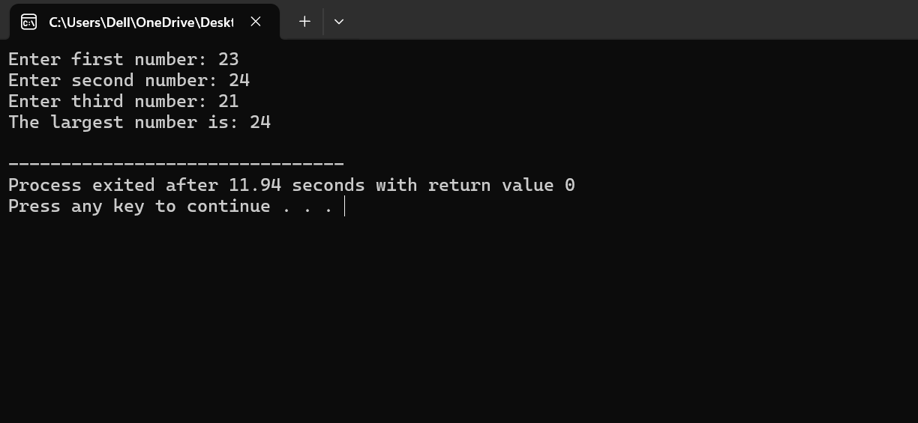

**12.Program to check two numbers are equal or notusing ternary conditional operator.**

**Program:**

#include <iostream>

using namespace std;

int main() {

int num1, num2;

cout<< "Enter first number: ";

cin>> num1;

cout<< "Enter second number: ";

cin>> num2;

string result = (num1 == num2) ? "The numbers are equal." : "The numbers are not equal.";

cout<< result <<endl;

return 0;

}

**Output:**

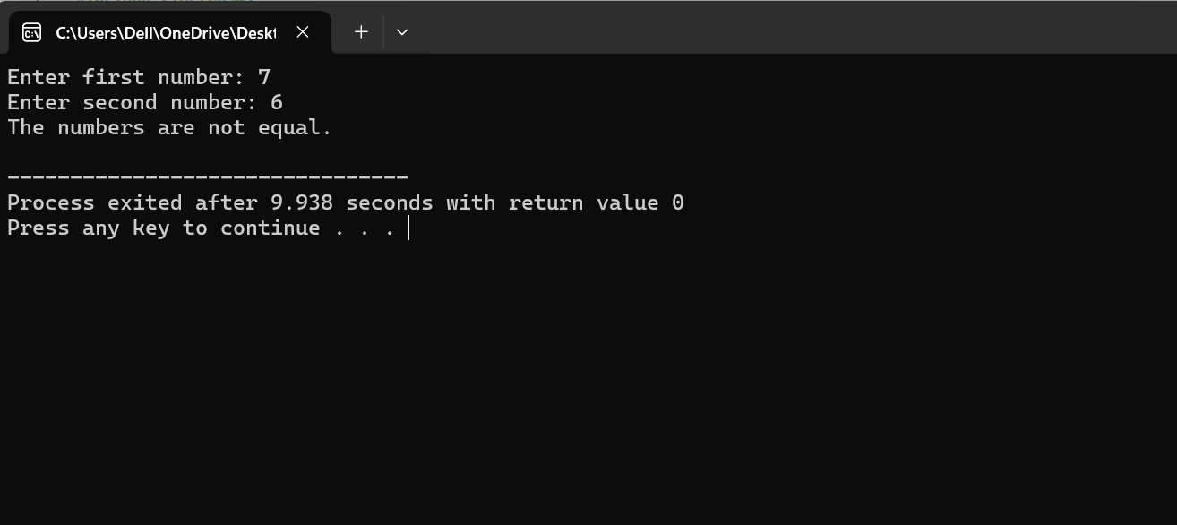

**13.Program to check the integer is divisible by 3 or not using ternary conditional operator.**

**Program:**

#include <iostream>

using namespace std;

int main() {

int num;

cout<< "Enter an integer: ";

cin>>num;

string result = (num % 3 == 0) ? "The integer is divisible by 3." : "The integer is not divisible by 3.";

cout<< result <<endl;

return 0;

}

**Output:**

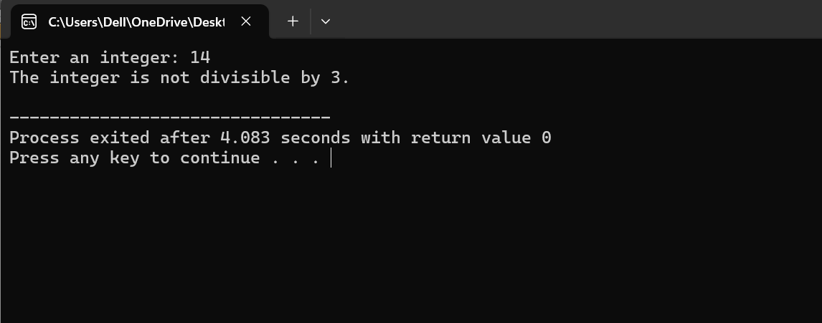

**14.Program to print numbers from 1 to 10 using for loop.**

**Program:**

#include <iostream>

using namespace std;

int main() {

cout<< "Numbers from 1 to 10:" <<endl;

for (int i = 1; i<= 10; ++i) {

cout<<i<< " ";

}

cout<<endl;

return 0;

}

**Output:**

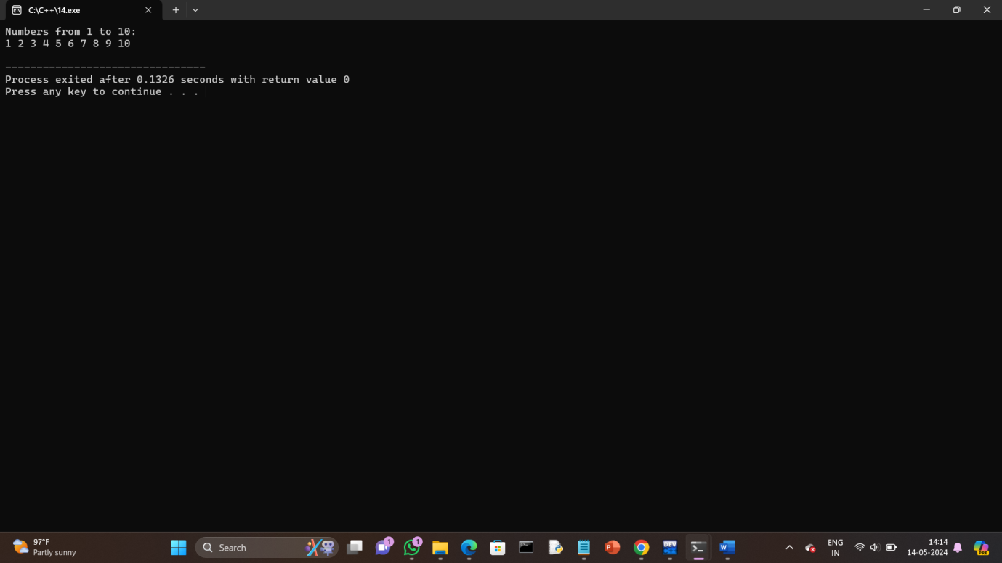

**15.Factorial of a number using for loop.**

**Program:**

#include <iostream>

using namespace std;

int main() {

int num;

unsigned long long factorial = 1;

cout<< "Enter a positive integer: ";

cin>>num;

if (num< 0) {

cout<< "Error: Factorial is not defined for negative numbers." <<endl;

return 1;

}

for (int i = 1; i<= num; ++i) {

factorial *= i;

}

cout<< "Factorial of " <<num<< " = " << factorial <<endl;

return 0;

}

**Output:**

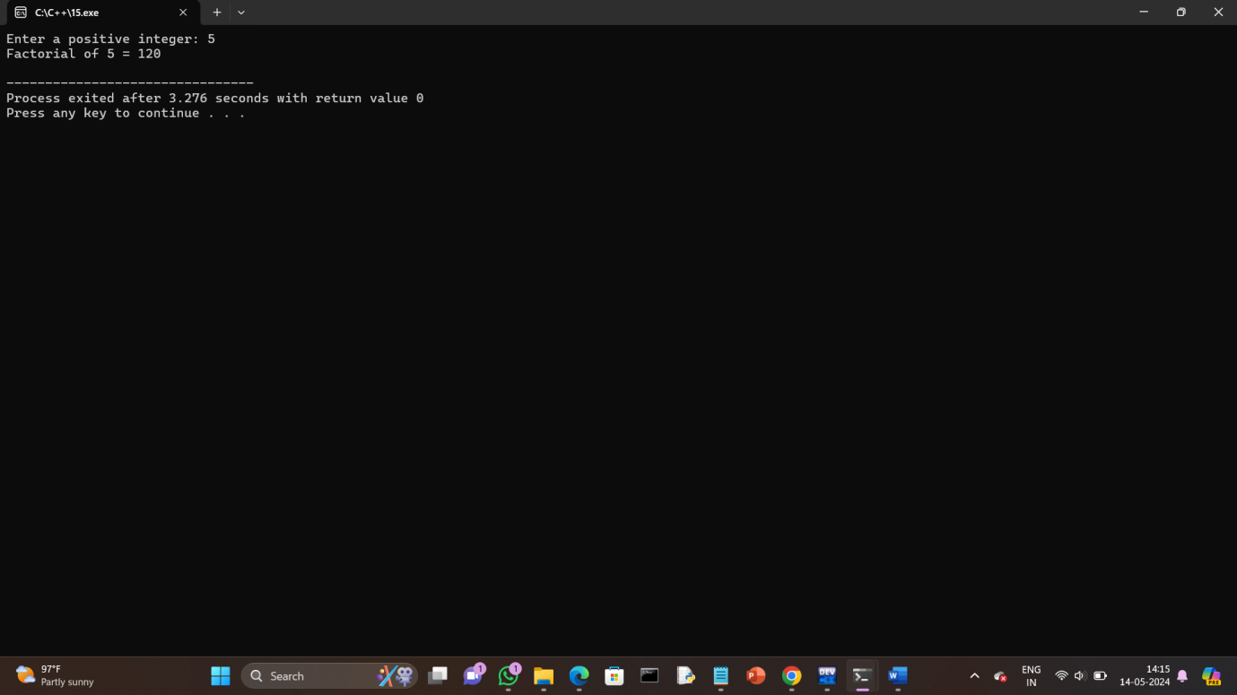

**16.Print multiplication table using for loop.**

**Program:**

#include <iostream>

using namespace std;

int main() {

int num;

cout<< "Enter the number to print its multiplication table: ";

cin>>num;

cout<< "Multiplication table of " <<num<< ":" <<endl;

for (int i = 1; i<= 10; ++i) {

cout<<num<< " * " <<i<< " = " <<num * i<<endl;

}

return 0;

}

**Output:**

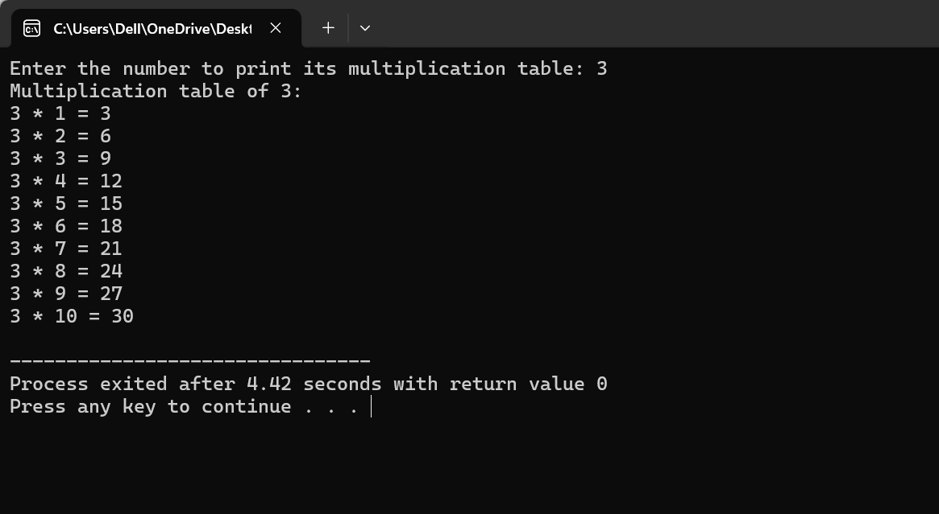

**17.Fibonacci series using for loop.**

**Program:**

#include <iostream>

using namespace std;

int main() {

int n;

cout<< "Enter the number of terms for Fibonacci series: ";

cin>> n;

int first = 0, second = 1;

cout<< "Fibonacci Series:" <<endl;

cout<< first << " " << second << " ";

for (int i = 2; i< n; ++i) {

int next = first + second;

cout<< next << " ";

first = second;

second = next;

}

return 0;

}

**Output:**

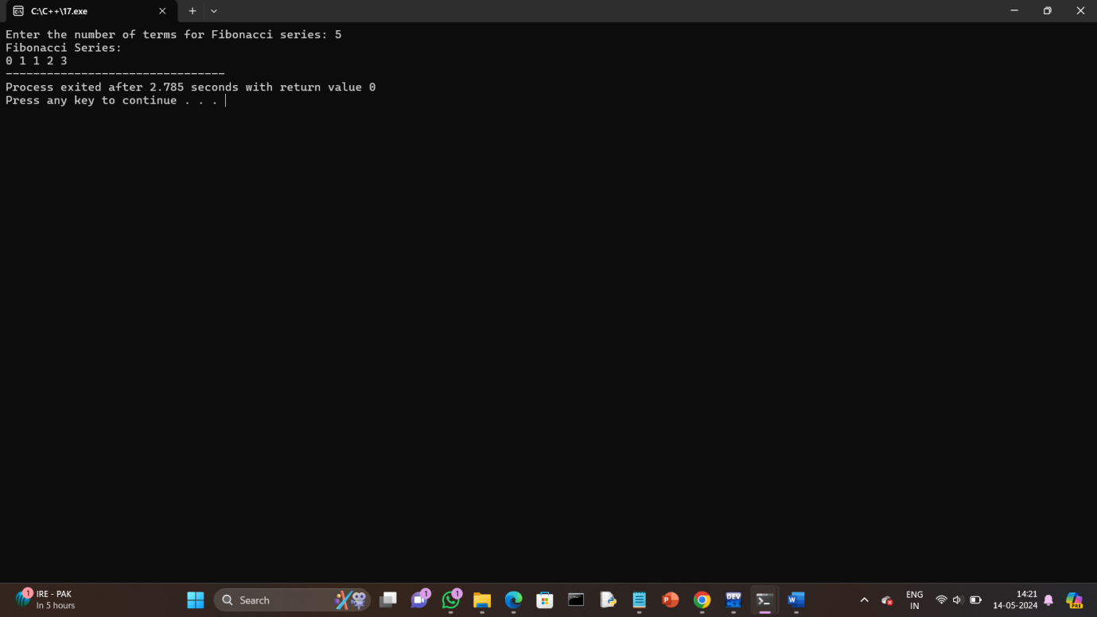

**18.Prime number using for loop.**

**Program:**

#include <iostream>

using namespace std;

int main() {

int num;

bool isPrime = true;

cout<< "Enter a positive integer: ";

cin>>num;

if (num<= 1) {

isPrime = false;

}

else {

for (int i = 2; i<= num / 2; ++i) {

if (num % i == 0) {

isPrime = false;

break;

}

}

}

if (isPrime) {

cout<<num<< " is a prime number." <<endl;

} else {

cout<<num<< " is not a prime number." <<endl;

}

return 0;

}

**Output:**

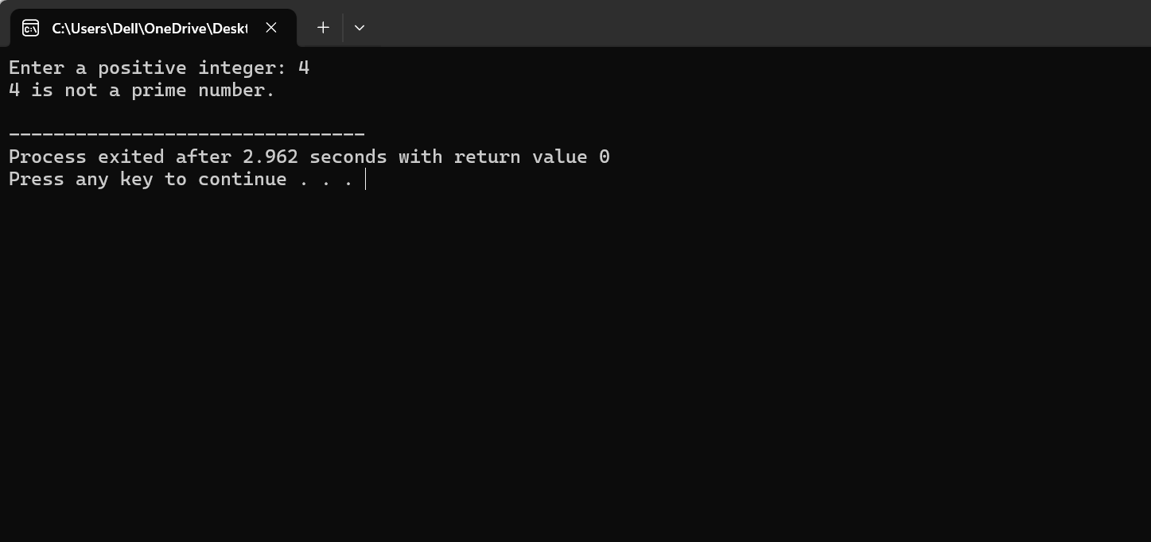

**19.Check the string is palindrome or not using while loop.**

**Program:**

#include <iostream>

#include <string>

#include <cctype>

using namespace std;

int main() {

string str;

bool isPalindrome = true;

cout<< "Enter a string: ";

getline(cin, str);

for (size_ti = 0; i<str.length(); ++i) {

str[i] = tolower(str[i]);

}

string cleanStr;

for (size_ti = 0; i<str.length(); ++i) {

if (isalnum(str[i])) {

cleanStr += str[i];

}

}

// Initialize start and end pointers

int start = 0;

int end = cleanStr.length() - 1;

while (start < end) {

if (cleanStr[start] != cleanStr[end]) {

isPalindrome = false;

break;

}

++start;

--end;

}

if (isPalindrome) {

cout<< "The string is a palindrome." <<endl;

} else {

cout<< "The string is not a palindrome." <<endl;

}

return 0;

}

**Output:**

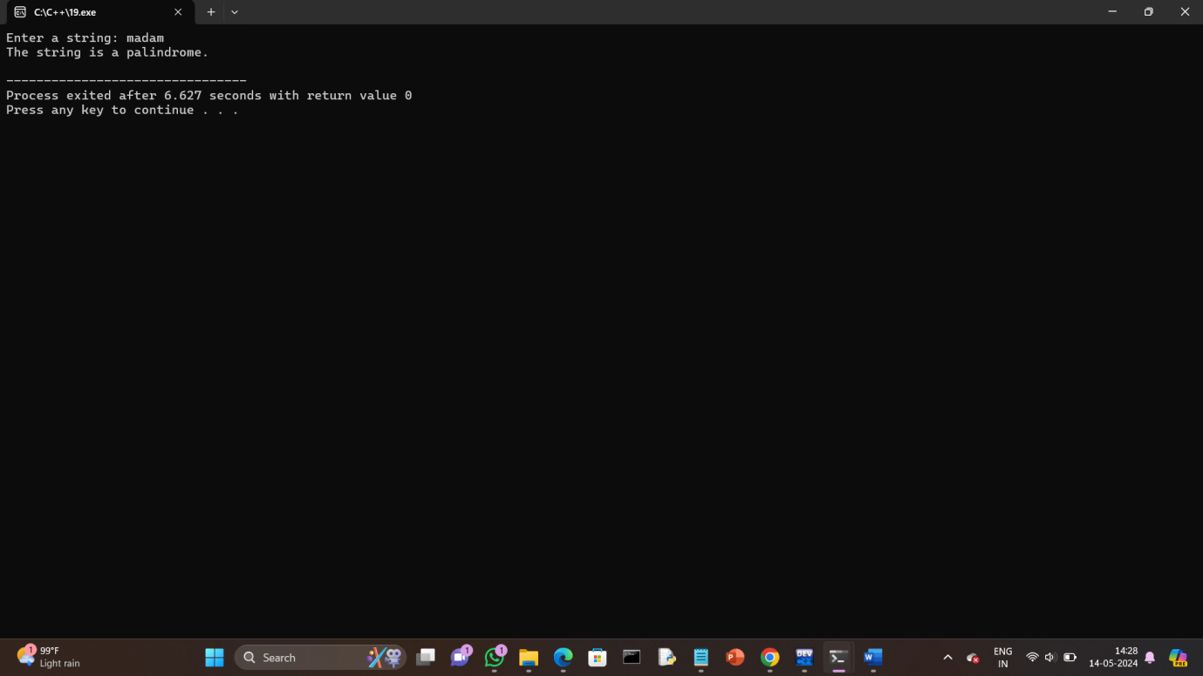

**20.Sum of all digits using while loop (n=123 output:1+2+3=6).**

**Program:**

#include <iostream>

using namespace std;

int main() {

int num, sum = 0, digit;

cout<< "Enter a number: ";

cin>>num;

int temp = num;

while (temp != 0) {

digit = temp % 10;

sum += digit;

temp /= 10;

}

cout<< "Sum of all digits in " <<num<< " = " << sum <<endl;

return 0;

}

**Output:**

